JCC0044/902521946
Computer Architecture
Homework 7
Theme: External Memory
All questions carry equal weight. Show your work.

- (DISK) Define track, cylinder and sector. Draw the disk format of a typical Winchester disk.
Track: One of the many concentric circular strips around the medium on a disk.
Cylinder: A set of one or more tracks on a rotating magnetic or optical storage device that can be read without moving the head.
Sector: The smallest unit of data that a magnetic storage device can read or write to or from the medium.
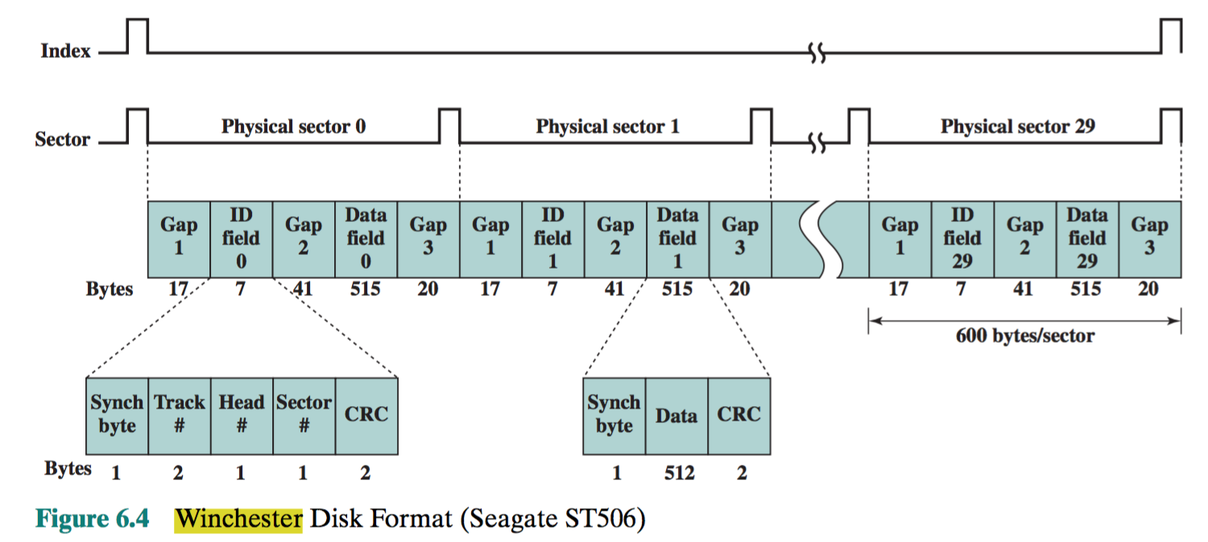

- (DISK/CD) Define rotational delay, access time and transfer time. Does the hard drive/CDROM run on CLV or CAV? Why is the capacity of DVD more than a CD?

Rotational Delay: when one of the three delays associated with reading or writing data on a computer's disk drive, and somewhat similar for CD or DVD drives. The others are seek time and transfer time, and their sum is access time. The term applies to rotating storage devices (such as a hard disk or floppy disk drive, and to the older drum memory systems). The rotational delay is the time required for the addressed area of the disk (or drum) to rotate into a position where it is accessible by the read/write head. Maximum rotational delay is the time it takes to do a full rotation (as the relevant part of the disk may have just passed the head when the request arrived). Most rotating storage devices rotate at a constant angular rate (constant number of revolutions per second). The maximum rotational delay is simply the reciprocal of the rotational speed (appropriately scaled). In 2001, 7200 revolutions per minute is typical for a hard disk drive; its maximum rotational delay will be 60/7200 s or about 8 ms. Average rotational delay is also a useful concept - it is half the maximum rotational delay.
Access time: In disk drives, disk access time is the time required for a computer to process data from the processor and then retrieve the required data from a storage device, such as a hard drive. For hard drives, disk access time is determined by a sum of the spin-up time, seek time, rotational delay and transfer time.
Transfer time: time during which data is actually read or written to medium, with a certain throughput.
The CD ROM operates in CLV mode.
- Bits are packed more closely on a DVD. The spacing between loops of a spiral on a CD is 1.6 μm and the minimum distance between pits along the spiral is 0.834 μm. The DVD uses a laser with shorter wavelength and achieves a loop spacing of 0.74 μm and a minimum distance between pits of 0.4 μm. The result of these two improvements is about a seven-fold increase in capacity, to about 4.7 GB.
- The DVD employs a second layer of pits and lands on top of the first layer. A dual-layer DVD has a semireflective layer on top of the reflective layer, and by adjusting focus, the lasers in DVD drives can read each layer separately. This technique almost doubles the capacity of the disk, to about 8.5 GB. The lower reflectivity of the second layer limits its storage capacity so that a full doubling is not achieved.
- The DVD-ROM can be two sided, whereas data are recorded on only one side of a CD. This brings total capacity up to 17 GB.

- Very briefly define the seven RAID levels, providing information about stripe size, synchronization, data transfer rate and their applications. (total less than a page)
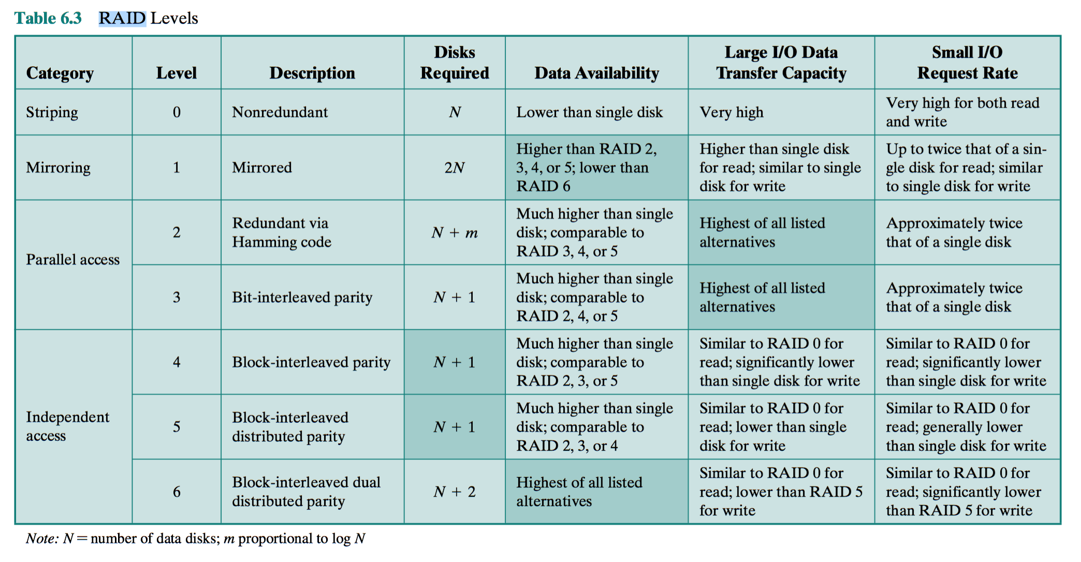
RAID 0 (also known as a stripe set or striped volume) splits ("stripes") data evenly across two or more disks, without parity information, redundancy, or fault tolerance. Since RAID 0 provides no fault tolerance or redundancy, the failure of one drive will cause the entire array to fail; as a result of having data striped across all disks, the failure will result in total data loss. This configuration is typically implemented having speed as the intended goal.^{[2][3]} RAID 0 is normally used to increase performance, although it can also be used as a way to create a large logical volumeout of two or more physical disks.^{[4]}
A RAID 0 setup can be created with disks of differing sizes, but the storage space added to the array by each disk is limited to the size of the smallest disk. For example, if a 120 GB disk is striped together with a 320 GB disk, the size of the array will be 120 GB × 2 = 240 GB.
The diagram in this section shows how the data is distributed into Ax stripes on two disks, with A1:A2 as the first stripe, A3:A4 as the second one, etc. Once the stripe size is defined during the creation of a RAID 0 array, it needs to be maintained at all times. Since the stripes are accessed in parallel, an n-drive RAID 0 array appears as a single large disk with a data rate n times higher than the single-disk rate.
A RAID 0 array of n drives provides data read and write transfer rates up to n times higher than the individual drive rates, but with no data redundancy. As a result, RAID 0 is primarily used in applications that require high performance and are able to tolerate lower reliability, such as inscientific computing^{[5]} or computer gaming.^{[6]}
Some benchmarks of desktop applications show RAID 0 performance to be marginally better than a single drive.^{[7][8]} Another article examined these claims and concluded that "striping does not always increase performance (in certain situations it will actually be slower than a non-RAID setup), but in most situations it will yield a significant improvement in performance".^{[9]} Synthetic benchmarks show different levels of performance improvements when multiple HDDs or SSDs are used in a RAID 0 setup, compared with single-drive performance. However, some synthetic benchmarks also show a drop in performance for the same comparison.^{[10][11]}
RAID 1 consists of an exact copy (or mirror) of a set of data on two or more disks; a classic RAID 1 mirrored pair contains two disks. This configuration offers no parity, striping, or spanning of disk space across multiple disks, since the data is mirrored on all disks belonging to the array, and the array can only be as big as the smallest member disk. This layout is useful when read performance or reliability is more important than write performance or the resulting data storage capacity.^{[12][13]}
The array will continue to operate so long as at least one member drive is operational.^{[14]}
Any read request can be serviced and handled by any drive in the array; thus, depending on the nature of I/O load, random read performance of a RAID 1 array may equal up to the sum of each member's performance,^{[a]} while the write performance remains at the level of a single disk. However, if disks with different speeds are used in a RAID 1 array, overall write performance is equal to the speed of the slowest disk.^{[13][14]}
Synthetic benchmarks show varying levels of performance improvements when multiple HDDs or SSDs are used in a RAID 1 setup, compared with single-drive performance. However, some synthetic benchmarks also show a drop in performance for the same comparison.^{[10][11]}
RAID 2 stripes data at the bit (rather than block) level, and uses a Hamming code for error correction. The disks are synchronized by the controller to spin at the same angular orientation (they reach index at the same time^{[clarification needed]}), so it generally cannot service multiple requests simultaneously. Extremely high data transfer rates are possible.^{[15][16]}
With all hard disk drives implementing internal error correction, the complexity of an external Hamming code offered little advantage over parity so RAID 2 has been rarely implemented; it is the only original level of RAID that is not currently used.^{[15][16]}
RAID 3 consists of byte-level striping with a dedicated parity disk. RAID 3 is rarely used in practice. One of the characteristics of RAID 3 is that it generally cannot service multiple requests simultaneously, which happens because any single block of data will, by definition, be spread across all members of the set and will reside in the same location.^{[clarification needed]} Therefore, any I/O operation requires activity on every disk and usually requires synchronized spindles.
This makes it suitable for applications that demand the highest transfer rates in long sequential reads and writes, for example uncompressed video editing. Applications that make small reads and writes from random disk locations will get the worst performance out of this level.^{[16]}
The requirement that all disks spin synchronously (in a lockstep) added design considerations to a level that provided no significant advantages over other RAID levels, so it quickly became useless and is now obsolete.^{[15]} Both RAID 3 and RAID 4 were quickly replaced by RAID 5.^{[17]} RAID 3 was usually implemented in hardware, and the performance issues were addressed by using large disk caches.^{[16]}
RAID 4, which is rarely used in practice, consists of block-level striping with a dedicated parity disk. As a result of its layout, RAID 4 provides good performance of random reads, while the performance of random writes is low due to the need to write all parity data to a single disk.^{[18]}
In the example on the right, a read request for block A1 would be serviced by disk 0. A simultaneous read request for block B1 would have to wait, but a read request for B2 could be serviced concurrently by disk 1.
RAID 5 consists of block-level striping with distributed parity. Unlike in RAID 4, parity information is distributed among the drives. It requires that all drives but one be present to operate. Upon failure of a single drive, subsequent reads can be calculated from the distributed parity such that no data is lost.^{[5]} RAID 5 requires at least three disks.^{[19]}
In comparison to RAID 4, RAID 5's distributed parity evens out the stress of a dedicated parity disk among all RAID members. Additionally, read performance is increased since all RAID members participate in serving of the read requests.^{[20]}
RAID 6 extends RAID 5 by adding another parity block; thus, it uses block-level striping with two parity blocks distributed across all member disks.^{[21]}
According to the Storage Networking Industry Association (SNIA), the definition of RAID 6 is: "Any form of RAID that can continue to execute read and write requests to all of a RAID array's virtual disks in the presence of any two concurrent disk failures. Several methods, including dual check data computations (parity and Reed-Solomon), orthogonal dual parity check data and diagonal parity, have been used to implement RAID Level 6."^{[22]}
RAID 6 does not have a performance penalty for read operations, but it does have a performance penalty on write operations because of the overhead associated with parity calculations. Performance varies greatly depending on how RAID 6 is implemented in the manufacturer's storage architecture—in software, firmware, or by using firmware and specialized ASICs for intensive parity calculations. It can be as fast as a RAID 5 system with one fewer drive (same number of data drives).^{[23]}

- Discuss the effectiveness of data striping in RAID 0 for the following two cases:

- A single process requests large data sets
The advantage of this layout is that if a single I/O request consists of multiple logically contiguous strips, then up to n strips for that request can be handled in parallel, greatly reducing the I/O transfer time.
- Multiple processes request several small sized data
In a transaction-oriented environment, the user is typically more concerned with response time than with transfer rate. For an individual I/O request for a small amount of data, the I/O time is dominated by the motion of the disk heads (seek time) and the movement of the disk (rotational latency). In a transaction environment, there may be hundreds of I/O requests per sec- ond. A disk array can provide high I/O execution rates by balancing the I/O load across multiple disks. Effective load balancing is achieved only if there are typically multiple I/O requests outstanding. This, in turn, implies that there are multiple inde- pendent applications or a single transaction-oriented application that is capable of multiple asynchronous I/O requests. The performance will also be influenced by the strip size. If the strip size is relatively large, so that a single I/O request only involves a single disk access, then multiple waiting I/O requests can be handled in parallel, reducing the queuing time for each request.

- What is flash memory? What are the differences among NOR and NAND flashes?
A form of semiconductor memory is flash memory (so named because of the speed with which it can be reprogrammed). First introduced in the mid-1980s, flash memory is intermediate between EPROM and EEPROM in both cost and functionality. Like EEPROM, flash memory uses an electrical erasing technology. An entire flash memory can be erased in one or a few seconds, which is much faster than EPROM. In addition, it is possible to erase just blocks of memory rather than an entire chip. Flash memory gets its name because the microchip is organized so that a section of memory cells are erased in a single action or “flash.” However, flash memory does not provide byte-level erasure. Like EPROM, flash memory uses only one transistor per bit, and so achieves the high density (compared with EEPROM) of EPROM.
There are two distinctive types of flash memory, designated as NOR and NAND. In NOR flash memory, the basic unit of access is a bit, and the logical organization resembles a NOR logic device.4 For NAND flash memory, the basic unit is 16 or 32 bits, and the logical organization resembles NAND devices. NOR flash memory provides high-speed random access. It can read and write data to specific locations, and can reference and retrieve a single byte. NOR flash memory is used to store cell phone operating system code and on Windows computers for the BIOS program that runs at startup. NAND reads and writes in small blocks. It is used in USB flash drives, memory cards (in digital cameras, MP3 players, etc.), and in SSDs. NAND provides higher bit density than NOR and greater write speed. NAND flash does not provide a random-access external address bus so the data must be read on a blockwise basis (also known as page access), where each block holds hundreds to thousands of bits.
- IEEE Computer magazine, August 2013 issue discusses Next Generation Memories. Write a 1-page report about next generation memories. (Single-spaced, 12 font Times New Roman)

The roots of the majority of memory technologies that are used in contemporary computing systems go back to early 1970s when the modern day semiconductor industry was in the nascent stage. These technologies include solid-state memories such as Static RAM (SRAM), Dynamic RAM (DRAM), and EPROM; and mechanical memories such as tape and the Hard Disk Drive (HDD). The scalability of these memory technologies has been a key factor in the emergence of the increasingly complex computing devices so far.
However, these conventional memory technologies are facing many challenges such as difficulties of miniaturization and reliability issues. The exponentially increasing demand for an enriched end-user experience and increased performance in Next Generation Memory Market mainstream computing applications is rendering these memory technologies obsolete. Driven by multi-core computing, virtualization, and processor integration trends, the global electronics and semiconductor industry has increasingly been feeling the need for next-generation main memory solutions that are capable of achieving data rates of up to 6400Mbps, with the same or lower power dissipation levels, as that of current advanced conventional memory solutions.
Many new memory technologies are in various stages of commercial development. Emerging memories are expected to replace most of the conventional memory technologies like flash memory. Next Generation Memory Market covered in this report are non-volatile next generation memory technologies such as Memristor or Resistive Random Access Memory (ReRAM), Phase Change Memory (PCM), Magneto-resistive Random Access Memory (MRAM), and Ferroelectric Random Access Memory (FeRAM), among other technologies. Emerging volatile next generation memory technologies included in the report are Static Random Access Memory (SRAM) and Dynamic Random Access Memory (DRAM), which include Synchronous DRAM (SDRAM), mobile DRAM, and other emerging DRAM technologies. Out of these memories, only MRAM and FeRAM account for a reasonable market share and they are quite commercialized in the market.
The semiconductor memory manufacturing industry is expected to face significant challenges over the next six to eight years period as it would witness the evolution of these emerging next generation memory technologies. The divergence of the two requirements of increasing performance while lowering power has posed a huge challenge for the future memory system designers.
The companies that are profiled in the report are SanDisk Corporation (U.S.), Toshiba Corporation (Japan), Intel Corporation (U.S.), Micron Technology, Inc. (U.S.), Adesto Technologies Corporation, Inc. (U.S.), Fujitsu Ltd. (Japan), SK Hynix Semiconducto, Inc. (South Korea), Samsung Electronics Co., Ltd. (South Korea), Cypress Semiconductor Corporation (U.S.), and IBM (U.S.), the total market for next generation memory is expected to reach up to $3.7 billion by 2020, at an estimated CAGR of 38.25% from 2014 to 2020.

